Howardson Dealer Portal

User Guides
21st March 2023

Table of Contents
Dealer Portal 3
Login & Forgot Password 3
Process an Opportunity 4
View / Download a Pricelist 4

Dealer Portal

The new dealer portal is a web, tablet and mobile friendly application that can be used to:
- Receive and update opportunities originating from the Howardson Group
- View and download official images and logos
- View and download pricelists (UK only)
- Find key contacts
The portal is by invitation only, it is not available to all dealers. To request an invitation or for general support, please contact us.

Login & Forgot Password
To login, please visit a Howardson Group website and click the ‘Dealer Login’ link in the top-right. Your email and password were sent to you when originally invited to the portal but to reset your password please:
- Click ‘forgot password’  - Enter the email you were registered with  - Click ‘reset password’  - If your account is found, a password reset email will be sent  - Follow the instructions in the email to reset your password | 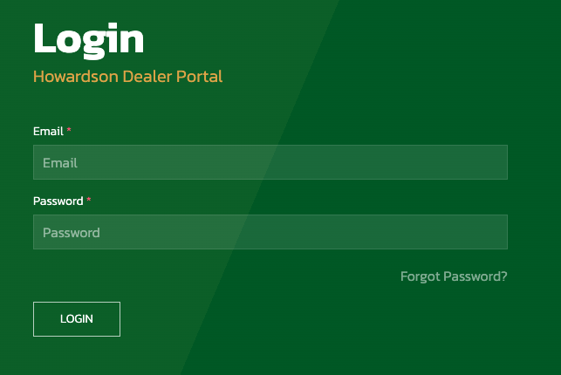

Process an Opportunity
New opportunities will be added to the opportunities page. Here you will see a list of all opportunities assigned to your dealership. We would encourage and appreciate if these could be updated with any significant progress and most importantly when they are Won or Lost.
- Click ‘opportunities’ on the nav menu  - Search for the opportunity or filter on ‘new’  - Click ‘details’ to view the opportunity details  - Click ‘update’:  - Update – to update progress  - Set to Lost – to close the opportunity as lost  - Set to Won – to close the opportunity as won  - Add the relevant information and click ‘submit’ | 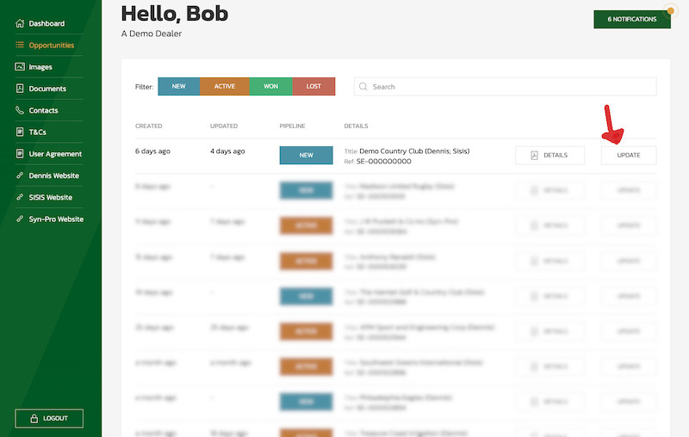

View / Download a Pricelist
Howardson Group assets such as images, logos, pricelists, and brochures can be found in the ‘Image’ and ‘Documents’ pages.
- Click ‘documents’ on the nav menu  - Click the tab for the brand  - Click download | 